Assignment #3

BLG 435E

Ece Naz Sefercioğlu

150130140

Q1)

a) Sims 3 is my favorite video game. It is an open world life simulation game that user can manipulate simulated character avatars.

As developer emphasizes [1], AI in game has two main goals, simulation of living world and achieving unique Sims characters. To achieve simulation of living world hierarchical planning, commodity-interaction maps, auto-satisfy curves and story-progression is used. Aim of hierarchical planning is to reduce branching factor that reduces complexity of action taken by AI. Commodity-interaction maps are used for preventing a sim to consider an action that would satisfies already satisfied need, only leading sim to possible actions that would satisfy yet to be satisfied needs. Auto-satisfy curves are used to have the sims’ needs always satisfied regularly, for example to satisfy hygiene need, AI will have the character use hygieneous objects in periods to not to have hygiene decrease too low. And lastly, story-progression is used to get the game world moving with accordance to desires of characters whether they are sims, towns or buildings. For instance if a dormitory building desires at least two empty beds and new sims use it, to have beds empty some of the dormitory members would die or get kicked out.

Creation of unique sims also depends on many parameters. For their action choosing logic, utility function is used with tuning of Maslow’s Hierarchy of Needs from real life. Personal traits are chosen from 80 traits and limited by 5 traits. Traits affect things that sims do, such as athletic sim may walk different than lazy sim. Also they have sims to choose social interactions in that area, wheter it is stalking or flirting. Moreover, by their personality constructed from traits when they are left alone to hands of AI, they act according to their traits. Workaholic sims would do things to skill up about their work, social sims would go meet strangers, mean-spirited sims would start a fight etc. Motives are goals for sims that is chosen by their traits and by the time passes with the experience of sim motives are changeable. What is more motives are effected by change of environment, as when it is dark scared sim may have a motive to use a taxi to go home than walking to destination if sun were out. Having many options to interaction, sims can have specialized actions on regular ones, such as compliment on house other than compliment, that ads granularity to sim’s actions.

In the lights of these information, it can be said AI is used intensely on Sims 3 and plays a big role in actions of uncontrolled sims. Other than sims, buildings also has desires that leads to actions. Overall desires and needs in game are affected by traits of the sims and they are again met in harmony with motives and traits of sims.

I can say they have good use of AI in their development. What can be added may be picking up what is the aim of the gamer and manipulate the world in accordance to it. For example, if the gamer wants to kill many sims so that she could construct a graveyard, AI may serve options such as electric shocks, meteoroid falls in more frequently periods or deaths of sims from other households done on the targeted household by some kind of action. For another example, if the gamer wants to construct a relationship between two sims, their fondness with each other may be increased by finding their common interests and have them act accordance to that interests by AI. Another technique would be a decision-making algorithm that is trained by gamer’s before preferences on creating sims and suggests randomly created sims from other possible creations may be done by gamer. This can reduce time spent on sim creation and have gamer feel special. How this works is as follows, gamer creates sims, and at the last one she chooses “random” option, sim suggested by system is created by taking before sim creations of gamer as reference. If most of the sims are long haired, suggested one may be long haired can be given as example.

2)

a)

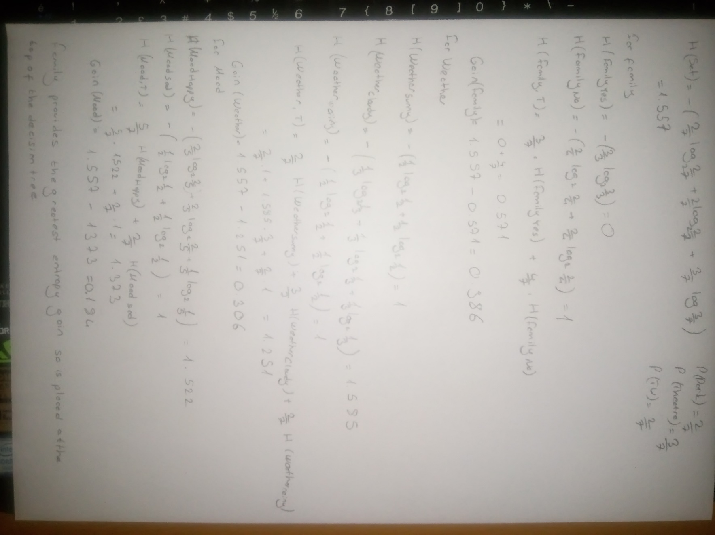

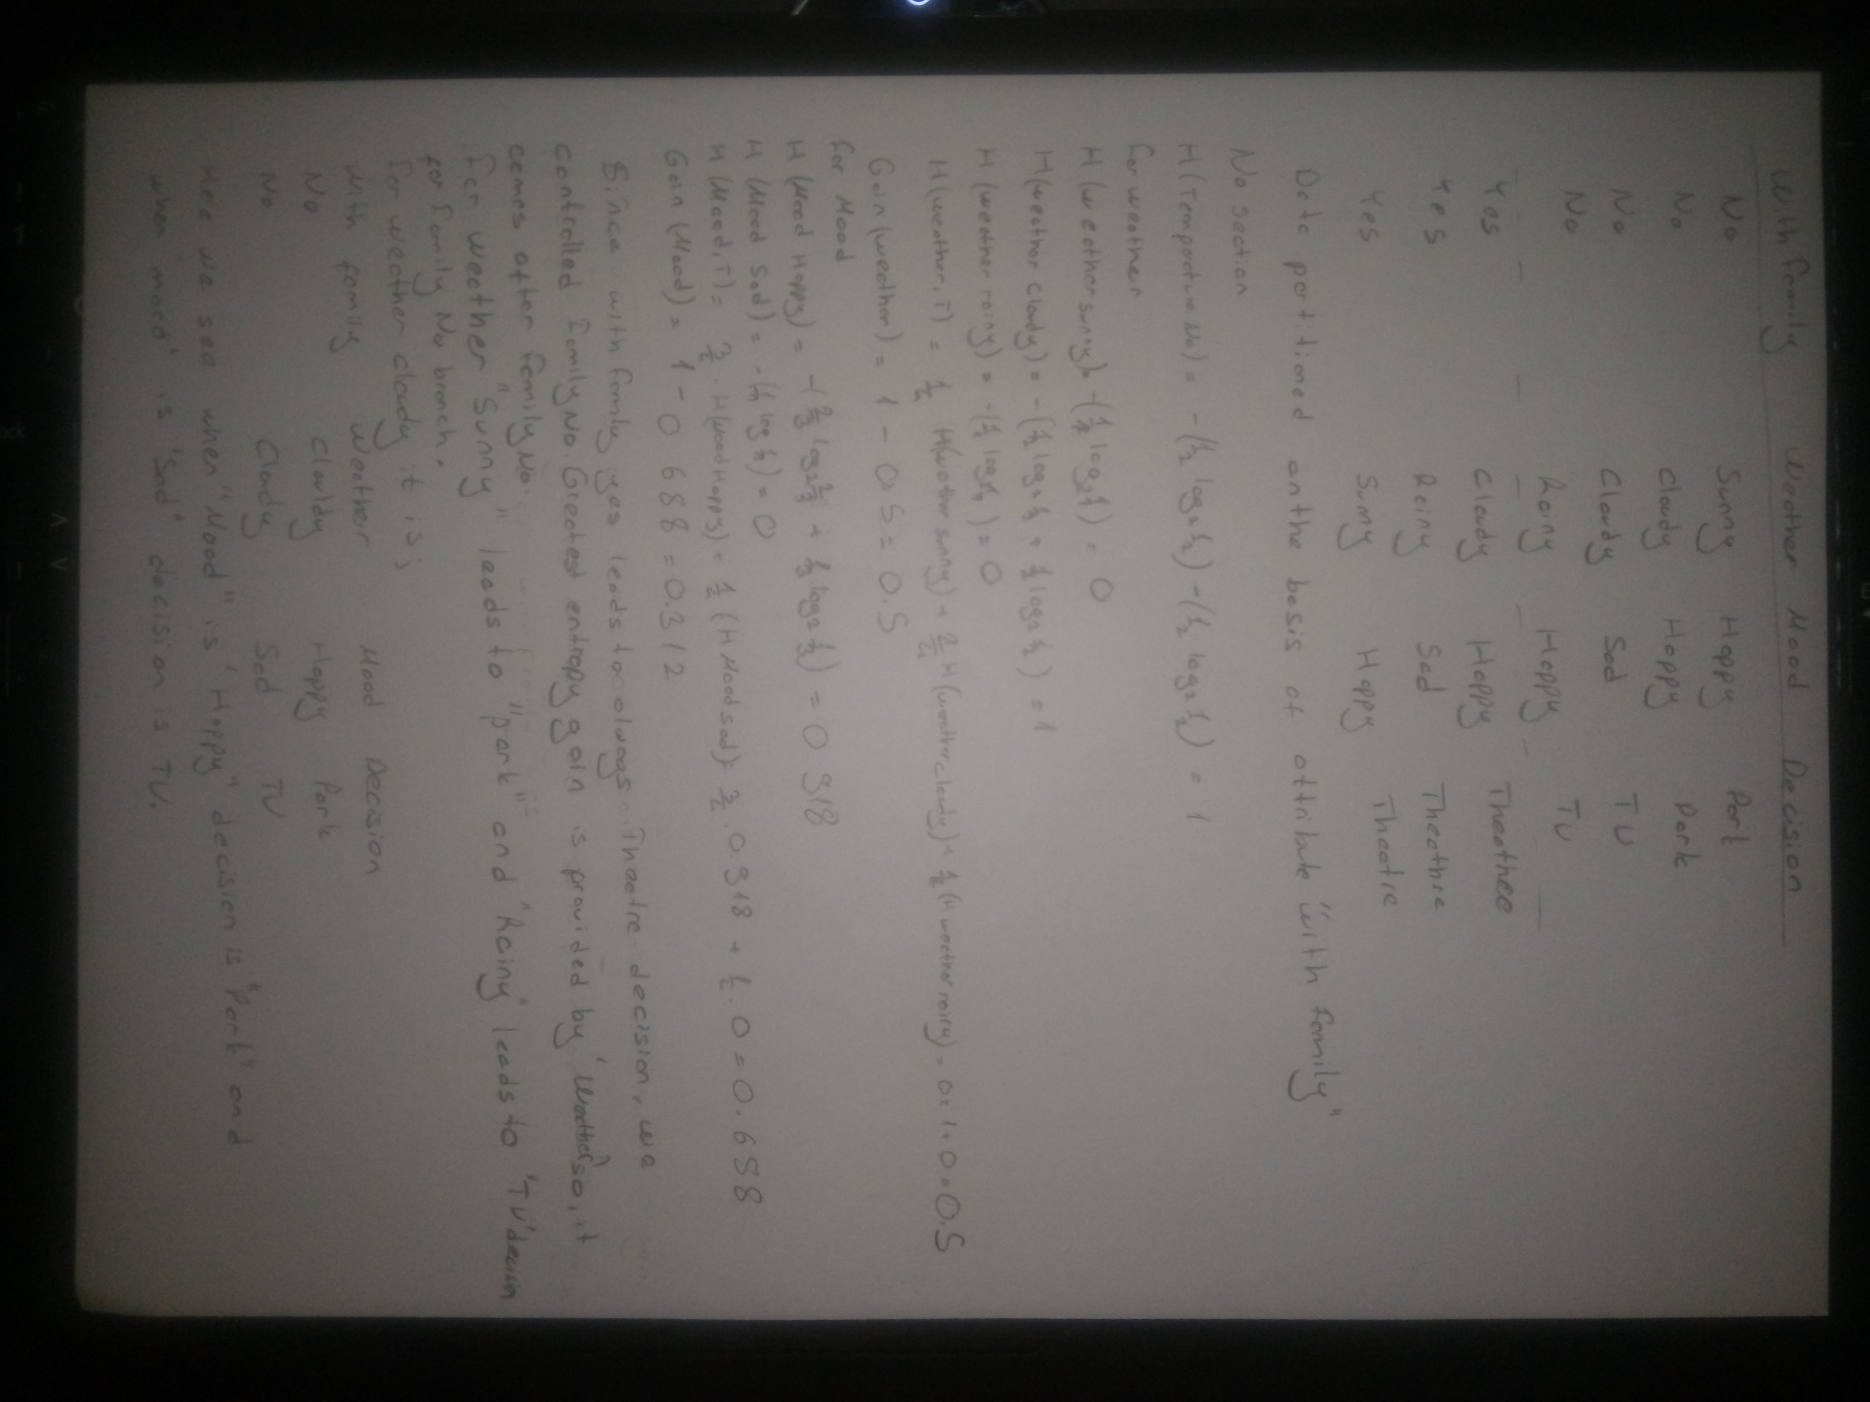

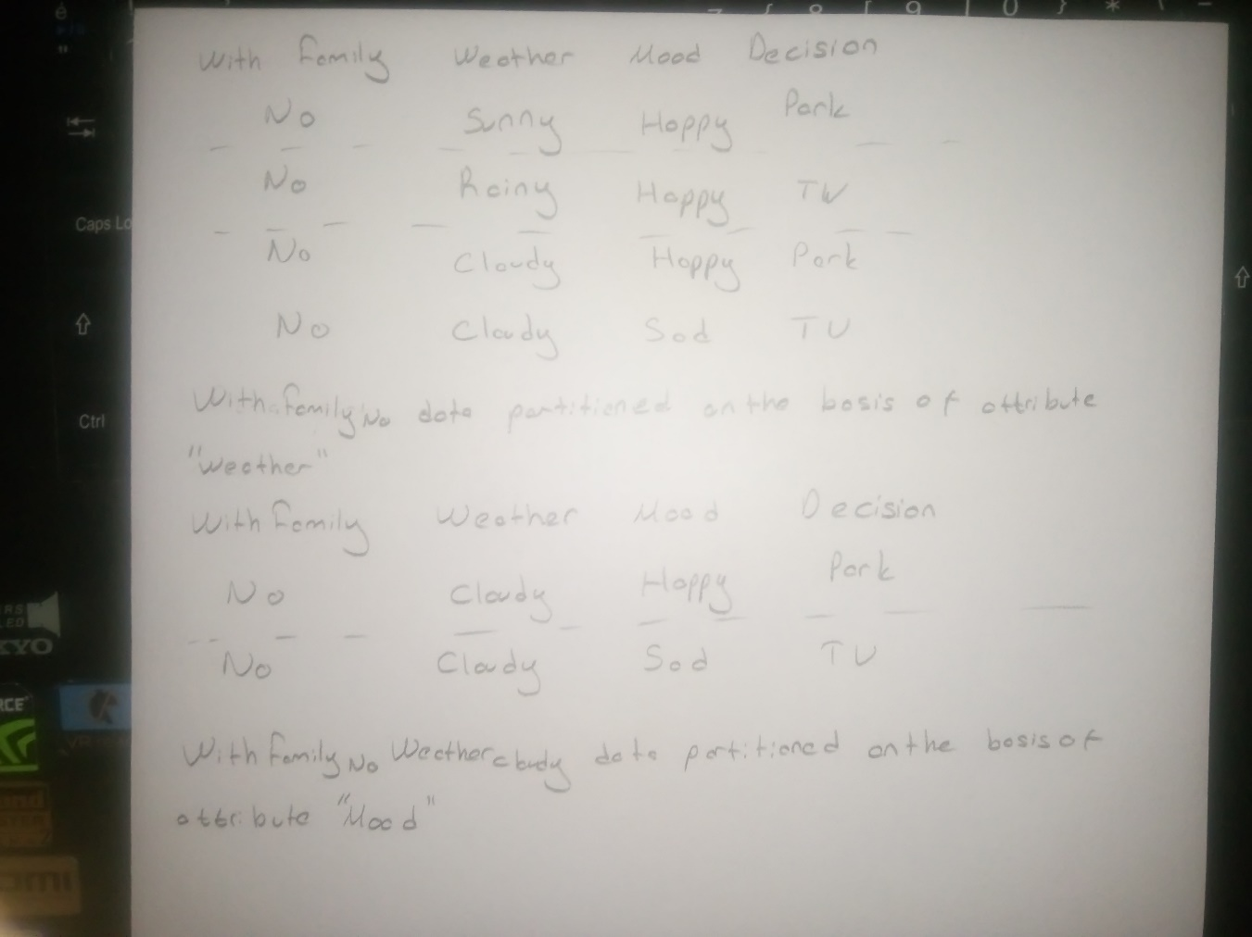

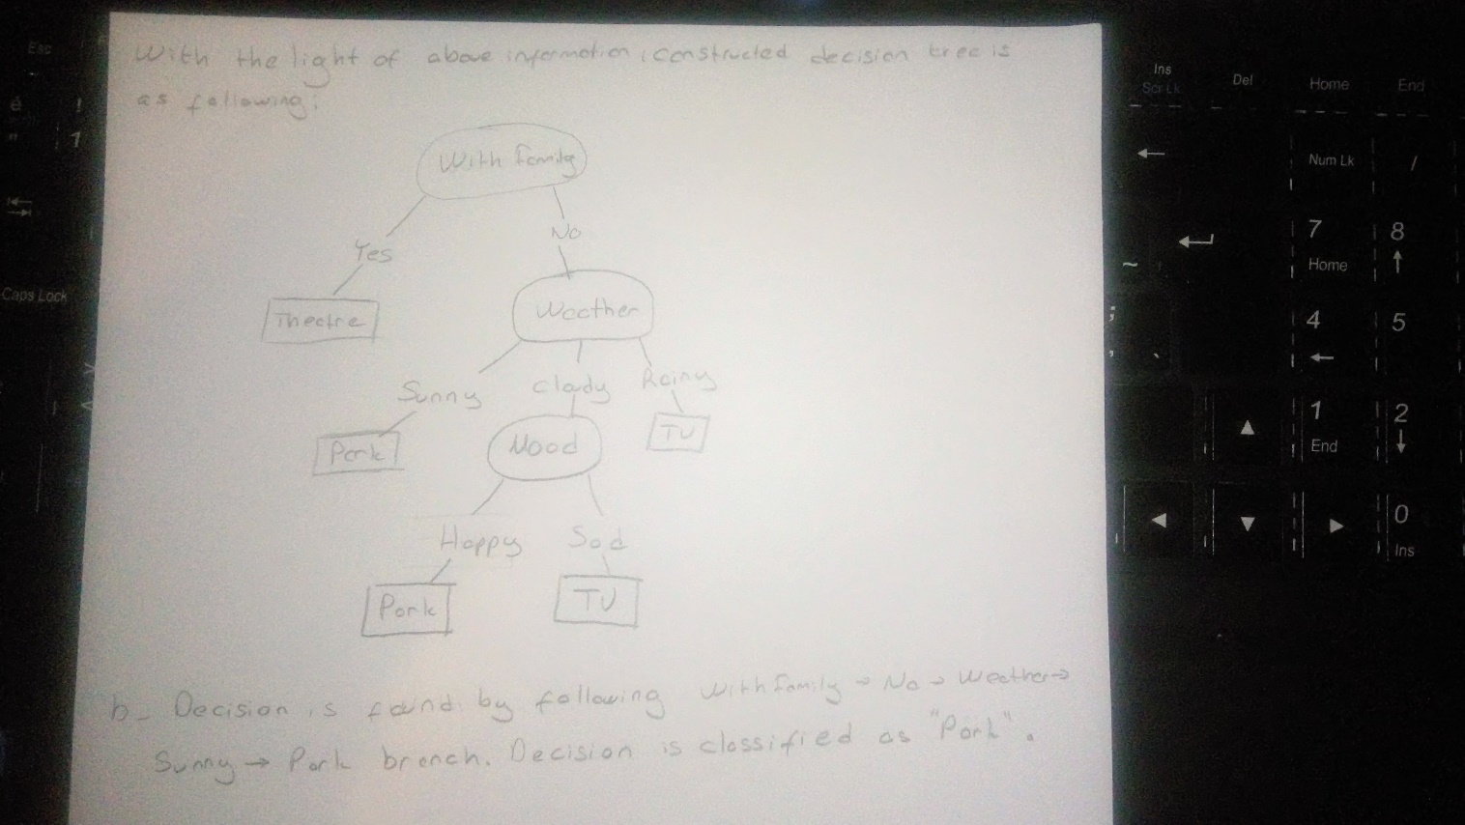

b)

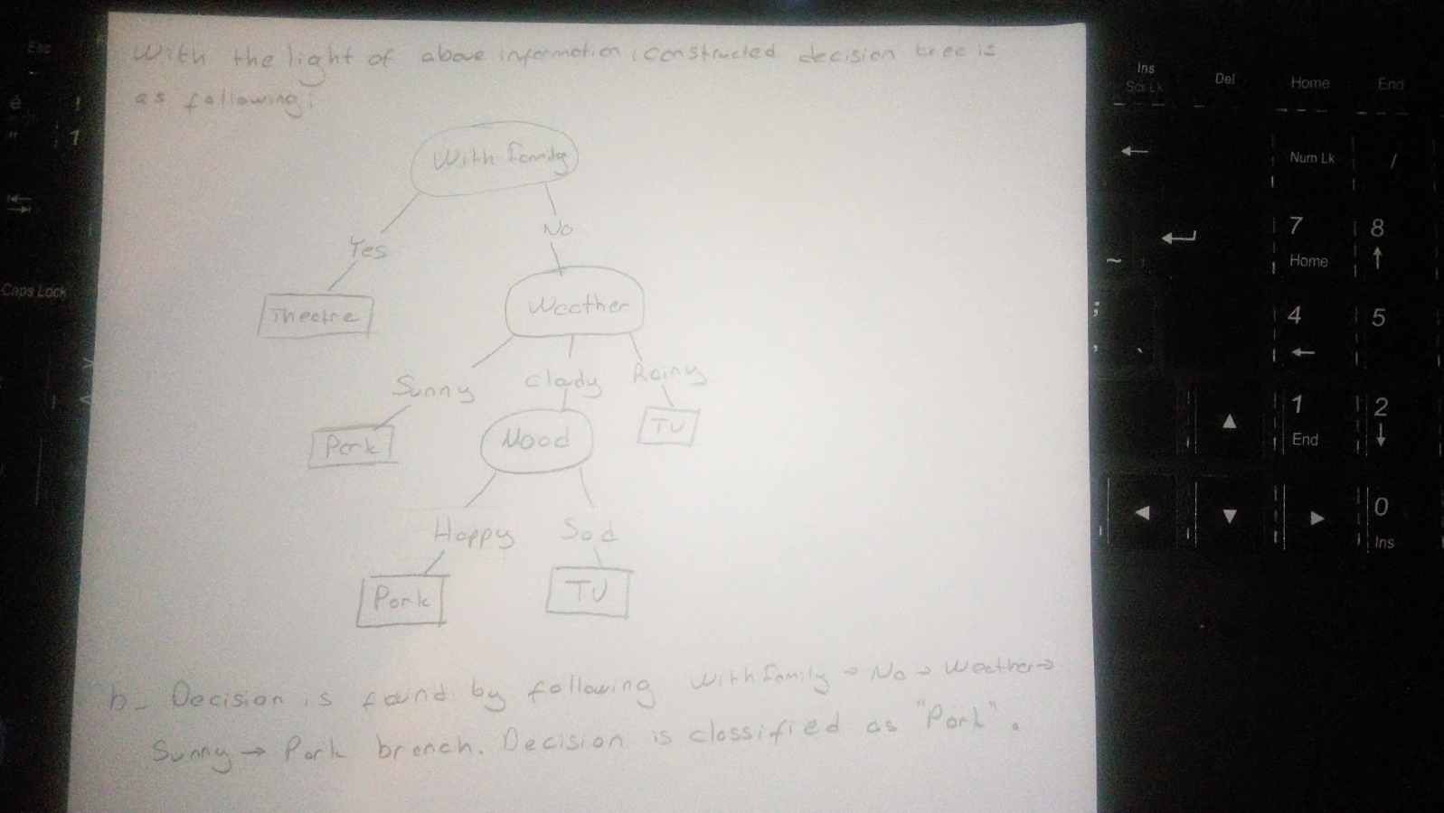

[1] http://www.gdcvault.com/play/1012450/Modeling-Individual-Personalities-in-The